**MyLogins Approved Requests**

* **ADD:-**

Once a MyLogins Add request has been approved, the following fields are populated as per the information provided in the webphone and the request itself.

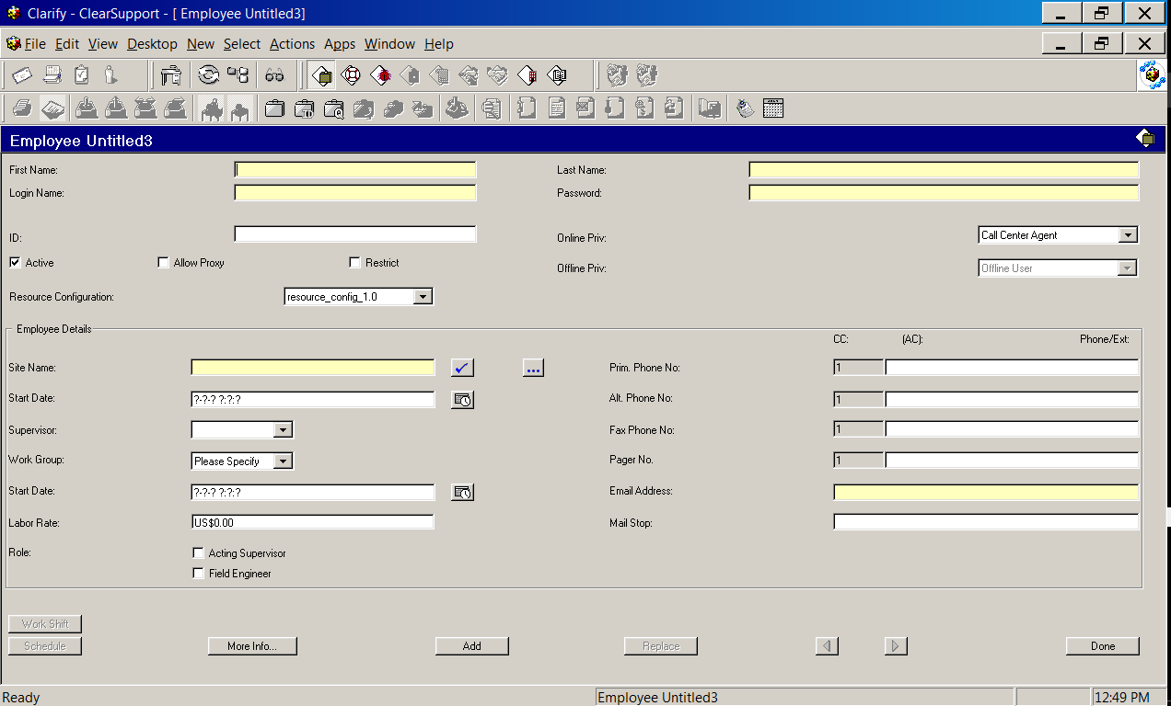

The fields populated here are First Name, Last Name, Login Name (Clarify ID), Password, Online Priv, Resource Configuration, Restrict indicator, Site Name and Email Address.

Once these fields are populated the user is added via ADD button at the bottom.  
  
A sql query is executed in the database in order to have the ID initiated with the system date followed by updating desired password in the Clarify GUI.

Once these steps are completed the user ID is good to go.

Further the details are populated in the MyLogins requests and status is change to completed and the request is completed.

* **CHANGE:-**

MyLogins Change requests are generally raised to change one or more fields mentioned in the Add segment above for already existing IDs but sometimes they are also raised in order to have the password reset performed for the user, however a USH ticket should be raised for the latter.

In case the request is to change the field such as First Name, Last Name, Password, Online Priv, Resource Configuration, Site Name and Email Address; the request can be provisioned however Login Name (Clarify ID) cannot be changed.

NOTE: Online Priv, Resource Configuration should not be changed once created since a Clarify login id looks like “psc_d_jk485w” psc implies the site, d implies service line and in this example it is DSL and jk485w is the attid of the user. Since login id cannot be changed if the Online priv is changed it could cause irregularities in the data.

In the scenario where other attributes need to be changed, the information is acquired from the MyLogins request, populated in the Clarify GUI and replaced with the existing data.

Once completed, the Mylogins request is updated with the same information and put to completed status.

* **DELETE:-**

There are two ways of removing a user ID from Clarify. Either of the methods can be implemented in order to successfully remove an ID from Clarify or provision the Delete request.

1. *Removing an ID from the GUI:-*  The Clarify ID to be removed is acquired from the MyLogins request and search is carried out based on multiple parameters to open a window similar to the following:

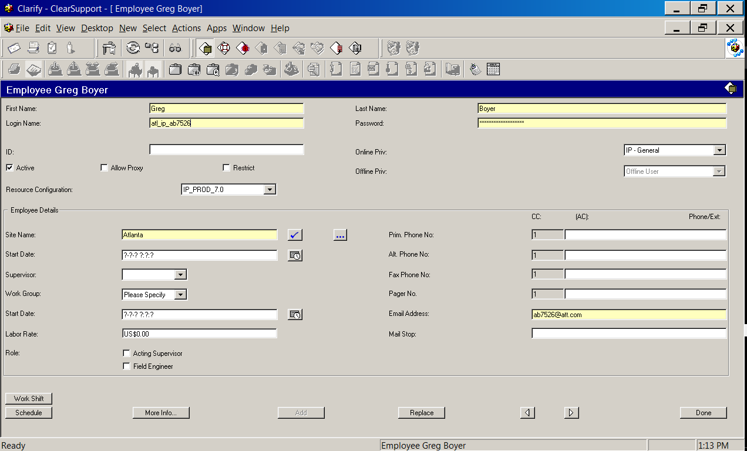

“Active” checkbox is unchecked and replaced. Once completed the user/login id is successfully rendered inactive or in other words deleted from Clarify.

1. *Removing an ID from the DB via script:-*  As in the previous method clarify login id to be removed is acquired from the MyLogins request and executed in the form of a sql query in the Clarify Production DB, where the status of the login name is turned 0. Hence in the process deleting the login id in Clarify.

This method is useful in the case where multiple login ids need to be removed simultaneously.

Once completed the information is updated in the MyLogins request and the request is set to completed and closed.